 | 12.1.11 Editors - Geometry Nodes Editor - Header - Add Menu - Geometry
Table of content
Detailed table of content 1
Add menu - Geometry 4
Bounding Box 4
Convex Hull 5
Delete Geometry 5
Duplicate Elements 6
Merge by Distance 6
Geometry to Instance 7
Geometry Proximity 7
Join Geometry 8
Raycast 9
Sample Index 10
Sample Nearest 11
Separate Components 11
Separate Geometry 12
Transform Geometry 13
Set ID 13
Set Position 14

Detailed table of content
Detailed table of content
Detailed table of content 1
Add menu - Geometry 4
Bounding Box 4
Inputs 4
Geometry 4
Output 4
Bounding Box 4
Min 4
Max 5
Convex Hull 5
Inputs 5
Geometry 5
Output 5
Convex Hull 5
Delete Geometry 5
Inputs 5
Geometry 5
Selection 5
Properties 5
Domain 5
Mode 5
Output 5
Geometry 5
Duplicate Elements 6
Inputs 6
Geometry 6
Selection 6
Amount 6
Properties 6
Domain 6
Output 6
Geometry 6
Duplicate Index 6
Merge by Distance 6
Input 7
Geometry 7
Selection 7
Distance 7
Properties 7
Mode 7
All 7
Connected 7
Output 7
Geometry 7
Geometry to Instance 7
Inputs 7
Geometry 7
Outputs 7
Instances 7
Geometry Proximity 7
Inputs 8
Target 8
Result 8
Position 8
Properties 8
Target Geometry 8
Outputs 8
Position 8
Distance 8
Join Geometry 8
Inputs 8
Geometry 8
Output 8
Geometry 8
Raycast 9
Inputs 9
Target Geometry 9
Attribute 9
Source Position 9
Ray Direction 9
Ray Length 9
Properties 9
Data Type 9
Mapping 9
Output 9
Is Hit 9
Hit Position 9
Hit Normal 10
Hit Distance 10
Attribute 10
Sample Index 10
Inputs 10
Geometry 10
Value 10
Index 10
Properties 10
Data Type 10
Domain 10
Clamp 10
Output 11
Value 11
Sample Nearest 11
Inputs 11
Geometry 11
Sample Position 11
Properties 11
Domain 11
Output 11
Index 11
Separate Components 11
Inputs 11
Geometry 11
Outputs 11
Mesh 11
Point Cloud 12
Curve 12
Volume 12
Instance 12
Separate Geometry 12
Inputs 12
Geometry 12
Selection 12
Properties 12
Domain 12
Outputs 12
Selection 12
Inverted 12
Transform Geometry 13
Inputs 13
Geometry 13
Translation 13
Rotation 13
Scale 13
Output 13
Geometry 13
Set ID 13
Inputs 13
Geometry 13
Selection 13
ID 13
Outputs 14
Geometry 14
Set Position 14
Inputs 14
Geometry 14
Selection 14
Position 14
Offset 14
Outputs 14
Geometry 14

Add menu - Geometry
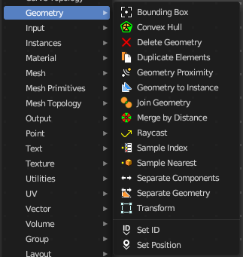
Here you find nodes to modify the geometry.

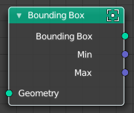
Bounding Box
The Bounding Box geometry node allows you to work with the values of a bounding box.

Inputs

Geometry
Standard geometry input.

Output

Bounding Box
Standard output.

Min
The minimum values of the bounding box.

Max
The maximum values of the bounding box.

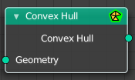
Convex Hull
The node allows you to work with the values of a convex hull of this object.

Inputs

Geometry
Standard geometry input.

Output

Convex Hull
Standard output.

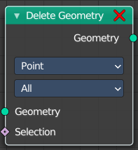
Delete Geometry
The node allows you to work with the values of a convex hull of this object.

Inputs

Geometry
Standard geometry input.

Selection
A selection of the geomerty

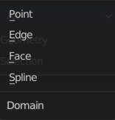
Properties

Domain
What element to delete.

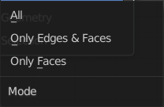
Mode
Delete mode. Names should be self explaining.

Output

Geometry
Standard output.

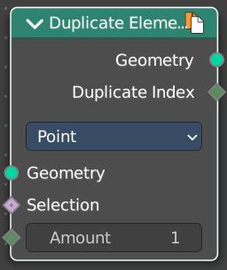
Duplicate Elements
Duplicates a part of a geometry a dynamic number of times.

Inputs

Geometry
Standard geometry input.

Selection
A selection of the geomerty.

Amount
Number of times the geometry should be duplicated.

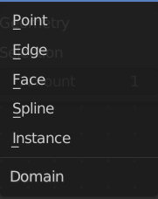
Properties

Domain
What element to duplicate.

Output

Geometry
Standard output.

Duplicate Index
The index of the duplicated elements.

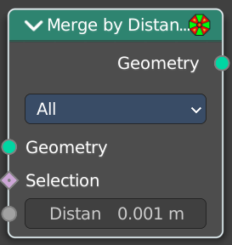
Merge by Distance
Welds the selected geometry below a given distance into one vertice.

Input

Geometry
The input geometry.

Selection
A selection of the input geometry.

Distance
The merge distance. Everything below this distance will be merged into one vertice.

Properties

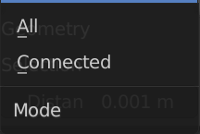
Mode

All
Merges all vertices in reach.

Connected
Merges just vertices that are connected by edges.

Output

Geometry
The output geometry.

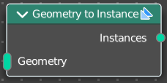
Geometry to Instance
Turns every connected input geometry into an instance. These instances can then for example be used in the Instance on Points node.

Inputs

Geometry
The input geometry.

Outputs

Instances
The output instances.

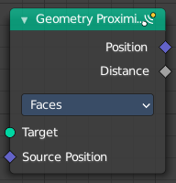
Geometry Proximity
This node finds the closest position on the target for each point in the input geometry.

Inputs

Target
The target object.

Result
Name of the attribute where the output is stored. If the attribute does not exist yet, it is created.

Position
The position where the computed location is stored.

Properties

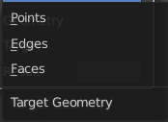
Target Geometry
The element of the target geometry to calculate the distance from.

Outputs

Position
Closest location on the surface of the target mesh, or the closest point in the target point cloud in Points mode.

Distance
Distance from the source position to the closest location in the target.

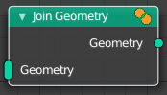
Join Geometry
The Join Geometry enables you to merge separately generated pieces of geometry into a single one. In case that the inputted pieces contain different types of geometry, the output will contain multiple types of geometry.

Inputs

Geometry
Standard geometry input.

Output

Geometry
Standard geometry output.

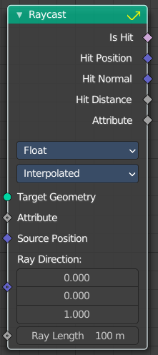
Raycast
This node sends a raycast and retreives data from the hit target.

Inputs

Target Geometry
This is actually the source object that sends the ray.

Attribute
Attribute input.

Source Position
Source position input.

Ray Direction
A vector 3 for the ray direction.

Ray Length
The length of the ray.

Properties

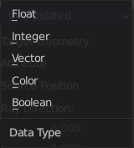
Data Type
What data to calculate on hit.

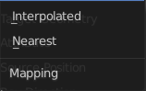
Mapping
Mapping from the target geometry to hit points. Interpolated or nearest.

Output

Is Hit
Has the raycast hit something?

Hit Position
The hit position if any.

Hit Normal
The normal of the hit point.

Hit Distance
The distance of the hit point.

Attribute
The attribute of the hit object.

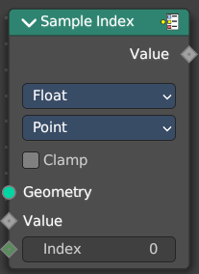
Sample Index
Retreive values from specific geometry elements

Inputs

Geometry
The source object to take the data from.

Value
The value to retreive.

Index
The index position of the value.

Properties

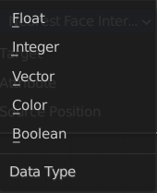
Data Type
The type for the source and result data.

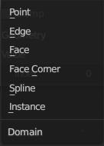
Domain
What kind of data to process.

Clamp
Clamp the indices to the size of the attribute domain.

Output

Value
The output value.

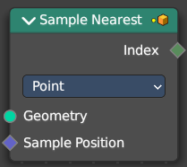
Sample Nearest
Retreives the element of a geometry closest to a position.

Inputs

Geometry
The source object to take the data from.

Sample Position
The position of the source object.

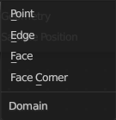
Properties

Domain
What data to process.

Output

Index
The index output.

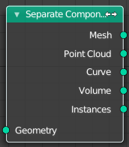
Separate Components
Splits a geometry into its components.

Inputs

Geometry
Geometry input.

Outputs

Mesh
Mesh component of the input geometry.

Point Cloud
Point cloud component of the input geometry.

Curve
Curve component of the input geometry.

Volume
Volume component of the input geometry.
In case that the input contains multiple volume instances, only the first volume component will be calculated.

Instance
The single instances of the geometry.

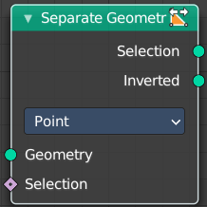
Separate Geometry
Separates a selection of a geometry into its own object.
Tip: when you combine it with the Compare Floats nodem then you get a more precise control of which parts are separated to a given output geometry.

Inputs

Geometry
Geometry input.

Selection
Selection input.

Properties

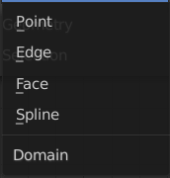
Domain
What kind of geometry to separate.
Note that when selecting a domain that doesn’t modify all components, the unmodified components will appear in both outputs.

Outputs

Selection
Separated selection.

Inverted
The inverted separated selection.

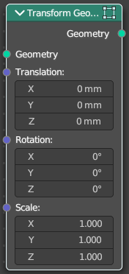
Transform Geometry
Move, rotate or scale the geometry. The transformation is applied to the entire geometry, and not per element. For example, you can not rotate individual point cloud points with this node.

Inputs

Geometry
Standard geometry input.

Translation
Translates the geometry in local space of the modified object.

Rotation
Euler rotation in local space.

Scale
Scale to transform the geometries in local space.

Output

Geometry
Standard geometry output.

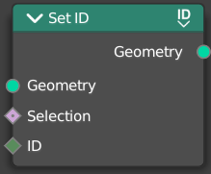
Set ID
Sets the ID of the target geometry.

Inputs

Geometry
Geometry input.

Selection
Selection input.

ID
ID Input

Outputs

Geometry
Geometry output.

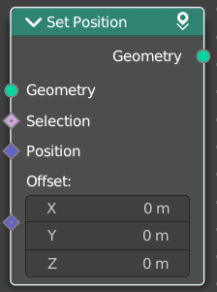
Set Position
The Set Position node controls the location of each point, the same way as controlling the position attribute. If the input geometry contains instances, this node will affect the location of the origin of each instance.
The input node for this data is the Position Node.

Inputs

Geometry
Geometry input.

Selection
Whether or not to change the position of each point or instance. True values mean the position will be changed, false values mean it will remain the same.

Position
The new position for selected elements. By default, this is the same as if the Position Node was connected, meaning the node will do nothing.

Offset
An optional translation for each point. This is evaluated at the same time as the Position input, meaning that fields evaluated for it will not reflect the changed position.

Outputs

Geometry
Geometry outputs.

